**1) Steps for creating a billing alarm notifications from the cloud watch console :-**

**a. First sing in to the aws console.**

**b. Make sure the region is set to U.S.East(N.virginia) this is the region .**

**c. Search for VPC interface**

**d. Type VPC in the AWS management console search box and then click Cloudwatch.**

**e. In the VPC go to create VPC.**

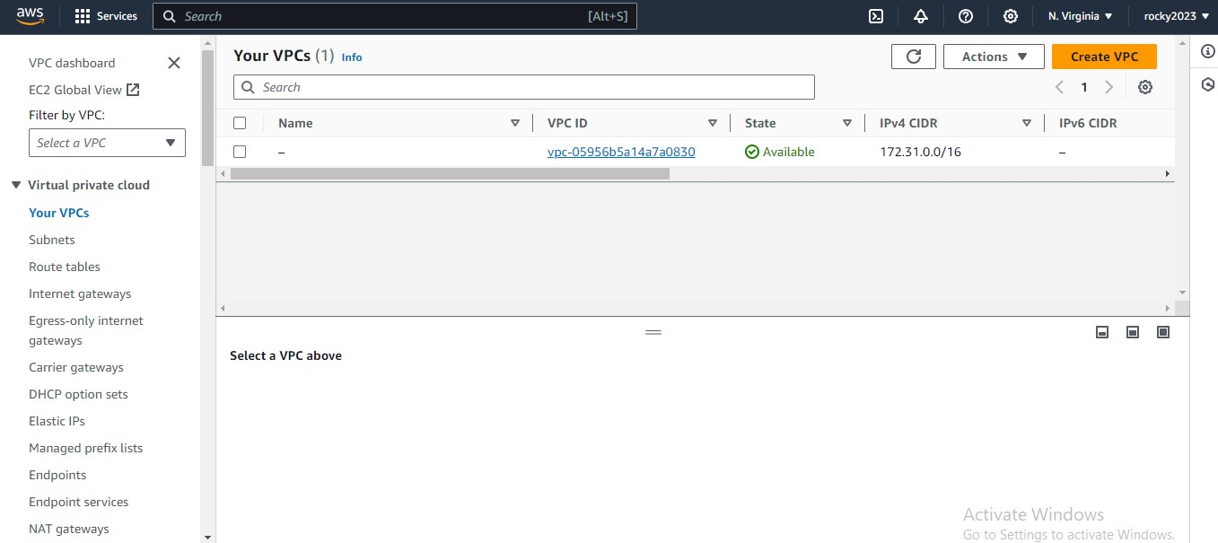

**2) Check in to the route table Click edit route check that route connected to igw or not.**

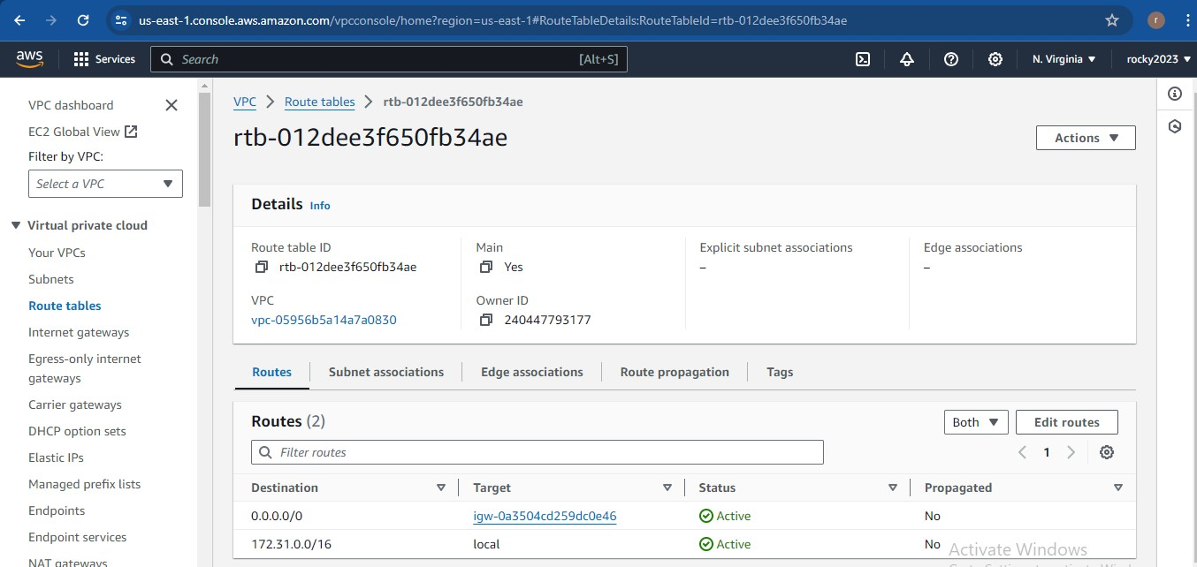

**3) Next go internate gateway and attach to vpc once check after attached.**

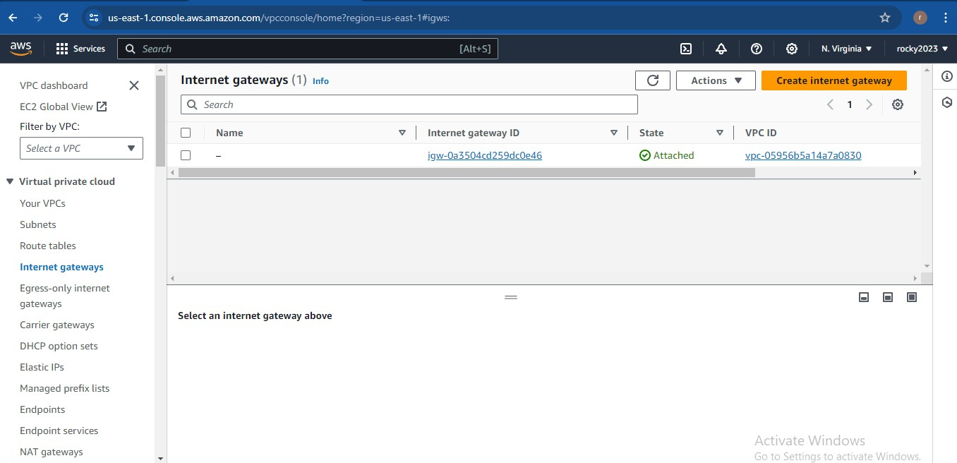

**4) Nect go to subnets cretate subnets like one for private and one for public and next do subnet association.**

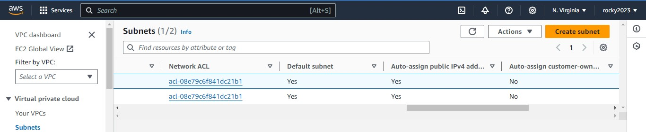

**5) Createting subnets as shown in below image.**

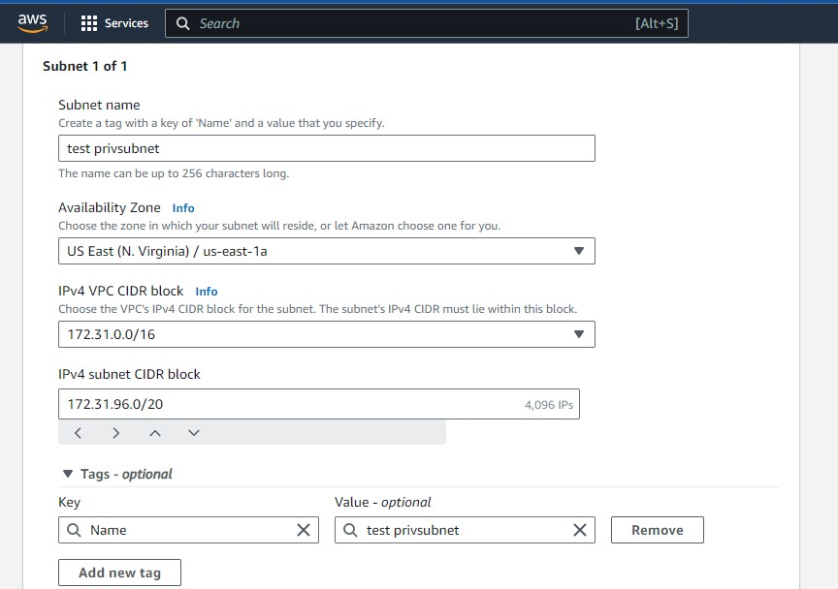

**6) Subnets created.**

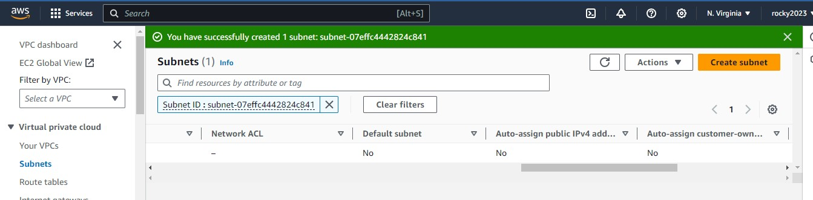

**7) Route table settings to be done .** 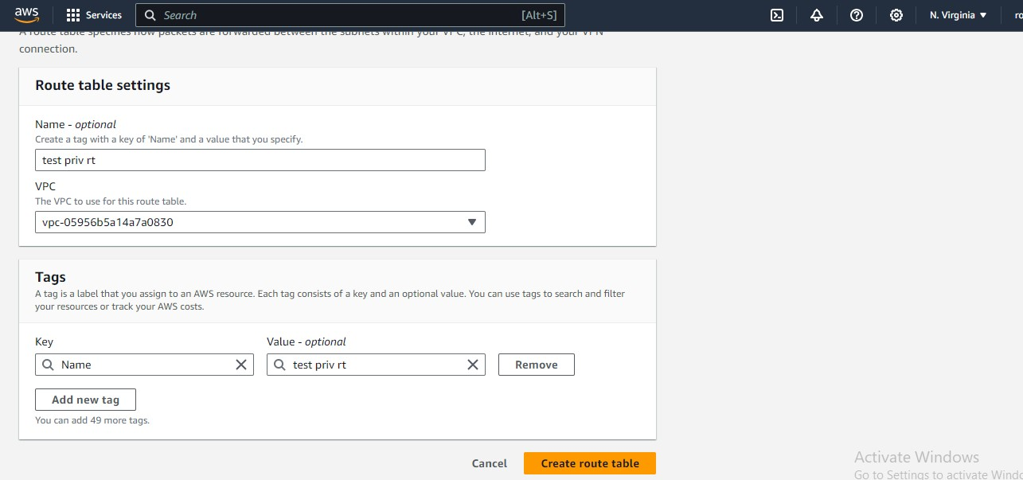

**8) Next edit subnet association and after adding subnets to vpc save association.**

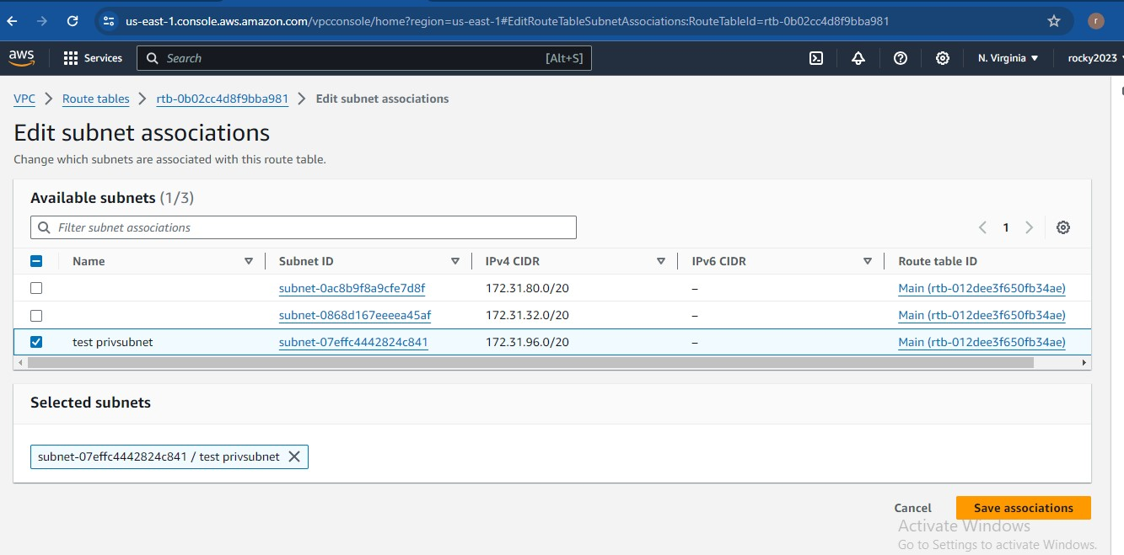

**9) Check the subnets that should be without associations.s**

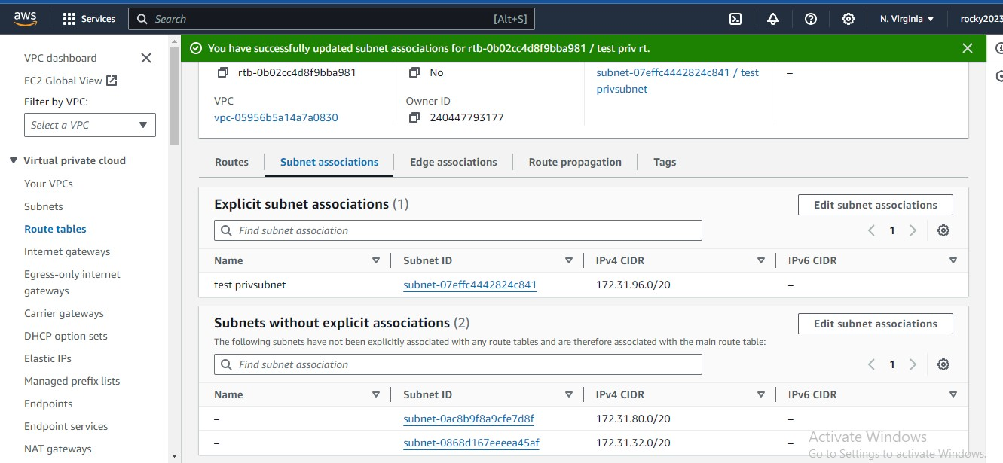

**10) Next part is to create instances one for private and one for public..**

**For to connect private instance from public IP address..**

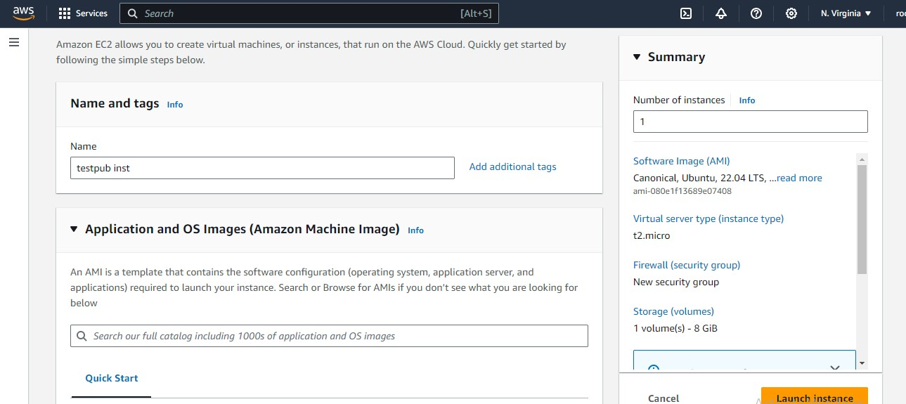

**11) Creating one more instance …2nd one.**

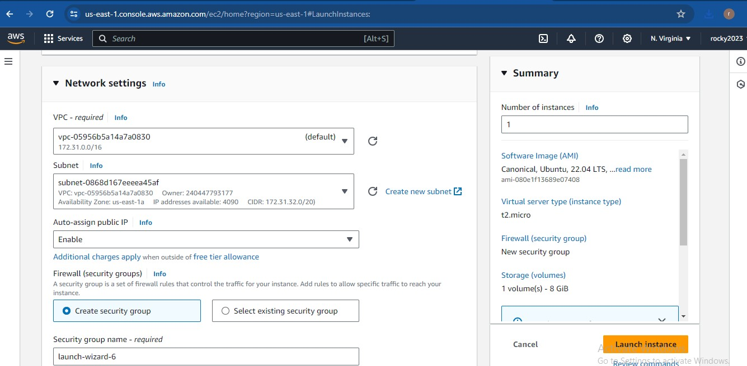

**12 ) Trying to connect from cli mode but shown some error.**

